Binary Tree Traversal and related properties
A binary tree T is defined as a finite set of nodes that is either empty or consists of a root and two disjoint binary trees TL and TR called, respectively, the left and right subtree of the root. Many problems about binary trees can be solved by applying the divide-and-conquer technique.

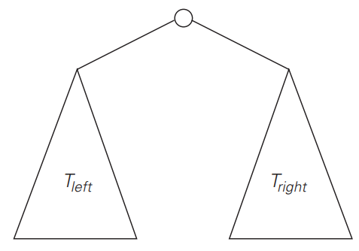

Figure a. Standard representation of a Binary Tree

It can be computed as the maximum of the heights of the root’s left and right subtrees plus 1. (1 is added to account for the extra level of the root)

Recursive algorithm to find the height of a binary tree:

Algorithm:- Height(T)
//Compares recursively the height of a binary tree
//Input: a binary tree t
//Output: the height of t
if T = ∅ return –1
else return max{Height(T_{l}), Height(T_{r})}+1

We measure the problem’s instance size by the number of nodes n(T ) in a given binary tree T . Obviously, the number of comparisons made to compute the maximum of two numbers and the number of additions A(n(T )) made by the algorithm are the same. We have the following recurrence relation for A(n(T )):
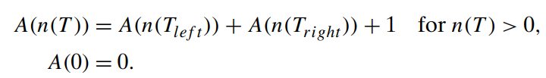
The binary tree traversals are as follows
- Preorder Traversal: The root is visited before left & right subtrees
- Inorder Traversal: The root is visited after visiting left subtree and before visiting right subtree
- Postorder Traversal: The root is visited after visiting the left and right subtrees

The binary tree extension can be drawn by replacing the empty subtrees by special nodes in a binary tree. The extra nodes shown as little squares are called external & the original nodes shown as little circles called internal. The extension of a empty binary tree is a single external node. The binary tree extension helps in analysis of tree algorithms.
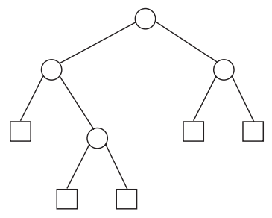
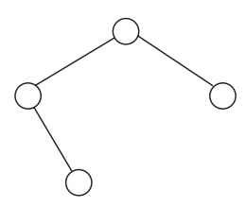

Figure a. Binary tree Figure b. binary tree extension

In the above figure Internal nodes are shown as circles; external nodes are shown as squares.

Example:

Find the in order, Pre order, Post order traversals of a given Binary tree.
